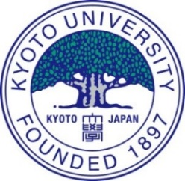
Kyoto University
APPLICATION FOR KYOTO IUP
FORM A: CERTIFICATE OF GRADUATION / EXPECTED GRADUATION

*Applicants must ask their school to process this document.

*Please note that this document must be prepared on school letterhead stationery. It must be produced by the school, signed by the school principal/head, and then given to the applicant. Alternatively, the document can be sent directly to the Kyoto iUP Admissions Office by registered mail if it is enclosed in a sealed envelope provided by the school.

The certificate is not required if the date of graduation/expected graduation from secondary school/high school is included in the school transcripts that also need to be submitted by the school.

The form on the following page must be completed and received by the Admissions Office between November 15 and December 28, 2018 via the Online Application System or by registered mail. If sending by registered mail, the address is as follows:

Kyoto iUP Admissions Office
Kyoto University
Yoshida International House Bldg. (B1), Yoshida South Campus,
Yoshida Nihonmatsu Cho, Sakyo-ku, Kyoto 606-8501, Japan
Tel.:+81-(0)75-753-3331

Thank you for your cooperation.

Kyoto iUP Admissions Office

Certificate of Graduation/Expected Graduation
(FORM A)

SCHOOL/INSTITUTION INFORMATION
Name of school/institution:
Address:
Phone: |  |  |  | Email:
URL:

APPLICANT INFORMATION
Name of Kyoto iUP applicant:
Date of birth:

This is to certify that the above-mentioned student enrolled at
on / /
(Name of Institution) (Month) (Date) (Year)
[is expected to complete / has completed] all the requirements for secondary/high school education and [is expected to graduate / graduated] from this
school on / / .
(Month) (Date) (Year)

Date of issue: / /
(Month) (Date) (Year)

) (Month) (Year)

Principal’s handwritten signature

Principal’s name in block letters

